Types of Software Testing
In this section, we are going to understand the various types of software testing, which can be used at the time of the Software Development Life Cycle.
As we know, software testing is a process of analyzing an application's functionality as per the customer prerequisite.
If we want to ensure that our software is bug-free or stable, we must perform the various types of software testing because testing is the only method that makes our application bug-free.
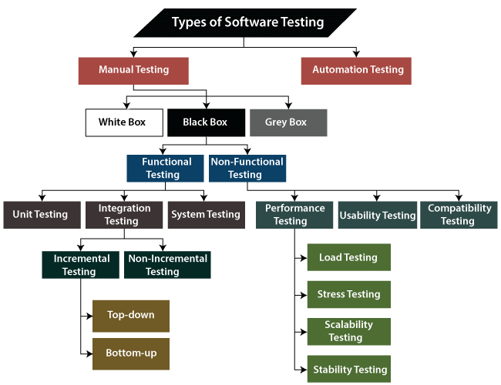

The different types of Software Testing
The categorization of software testing is a part of diverse testing activities, such as test strategy, test deliverables, a defined test objective, etc. And software testing is the execution of the software to find defects.
The purpose of having a testing type is to confirm the AUT (Application Under Test).
To start testing, we should have a requirement, application-ready, necessary resources available. To maintain accountability, we should assign a respective module to different test engineers.
The software testing mainly divided into two parts, which are as follows:
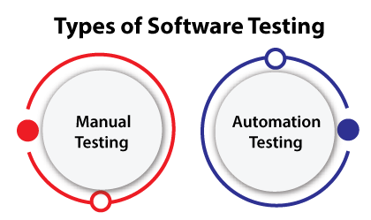
- Manual Testing
- Automation Testing

What is Manual Testing?
Testing any software or an application according to the client's needs without using any automation tool is known as manual testing.
In other words, we can say that it is a procedure of verification and validation. Manual testing is used to verify the behavior of an application or software in contradiction of requirements specification.
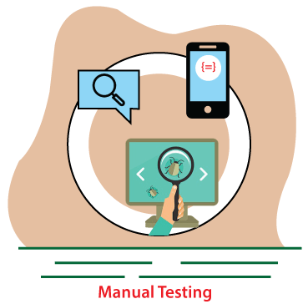
We do not require any precise knowledge of any testing tool to execute the manual test cases. We can easily prepare the test document while performing manual testing on any application.
To get in-detail information about manual testing, click on the following link: https://www.javatpoint.com/manual-testing.

Classification of Manual Testing
In software testing, manual testing can be further classified into three different types of testing, which are as follows:
- White Box Testing
- Black Box Testing
- Grey Box Testing
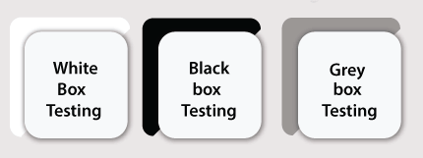
For our better understanding let's see them one by one:

White Box Testing
In white-box testing, the developer will inspect every line of code before handing it over to the testing team or the concerned test engineers.

Subsequently, the code is noticeable for developers throughout testing; that's why this process is known as WBT (White Box Testing).
In other words, we can say that the developer will execute the complete white-box testing for the particular software and send the specific application to the testing team.
The purpose of implementing the white box testing is to emphasize the flow of inputs and outputs over the software and enhance the security of an application.
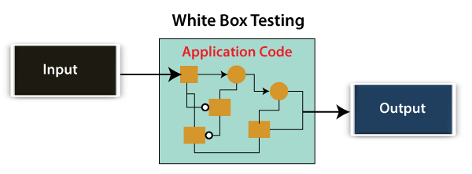
White box testing is also known as open box testing, glass box testing, structural testing, clear box testing, and transparent box testing.
To get the in-depth knowledge about white box testing refers to the below link: https://www.javatpoint.com/white-box-testing.

Black Box Testing
Another type of manual testing is black-box testing. In this testing, the test engineer will analyze the software against requirements, identify the defects or bug, and sends it back to the development team.

Then, the developers will fix those defects, do one round of White box testing, and send it to the testing team.
Here, fixing the bugs means the defect is resolved, and the particular feature is working according to the given requirement.
The main objective of implementing the black box testing is to specify the business needs or the customer's requirements.
In other words, we can say that black box testing is a process of checking the functionality of an application as per the customer requirement. The source code is not visible in this testing; that's why it is known as black-box testing.
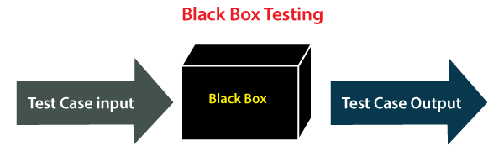
For more information about Black box testing, refers to the below link: https://www.javatpoint.com/black-box-testing.

Types of Black Box Testing
Black box testing further categorizes into two parts, which are as discussed below:
- Functional Testing
- Non-function Testing
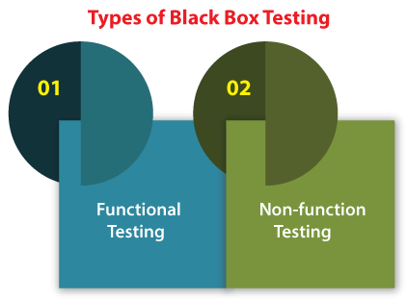

Functional Testing
The test engineer will check all the components systematically against requirement specifications is known as functional testing. Functional testing is also known as Component testing.
In functional testing, all the components are tested by giving the value, defining the output, and validating the actual output with the expected value.
Functional testing is a part of black-box testing as its emphases on application requirement rather than actual code. The test engineer has to test only the program instead of the system.
To get the detailed information about functional testing refers to the below link: https://www.javatpoint.com/functional-testing.

Types of Functional Testing
Just like another type of testing is divided into several parts, functional testing is also classified into various categories.
The diverse types of Functional Testing contain the following:
- Unit Testing
- Integration Testing
- System Testing
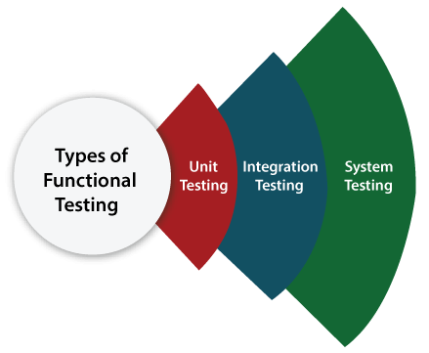
Now, Let's understand them one by one:

1. Unit Testing
Unit testing is the first level of functional testing in order to test any software. In this, the test engineer will test the module of an application independently or test all the module functionality is called unit testing.
The primary objective of executing the unit testing is to confirm the unit components with their performance. Here, a unit is defined as a single testable function of a software or an application. And it is verified throughout the specified application development phase.
Click on the below link to get the complete information about unit testing: https://www.javatpoint.com/unit-testing.

2. Integration Testing
Once we are successfully implementing the unit testing, we will go integration testing. It is the second level of functional testing, where we test the data flow between dependent modules or interface between two features is called integration testing.
The purpose of executing the integration testing is to test the statement's accuracy between each module.

Types of Integration Testing
Integration testing is also further divided into the following parts:
- Incremental Testing
- Non-Incremental Testing
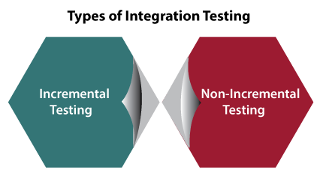

Incremental Integration Testing
Whenever there is a clear relationship between modules, we go for incremental integration testing. Suppose, we take two modules and analysis the data flow between them if they are working fine or not.
If these modules are working fine, then we can add one more module and test again. And we can continue with the same process to get better results.
In other words, we can say that incrementally adding up the modules and test the data flow between the modules is known as Incremental integration testing.
Types of Incremental Integration Testing
Incremental integration testing can further classify into two parts, which are as follows:
- Top-down Incremental Integration Testing
- Bottom-up Incremental Integration Testing
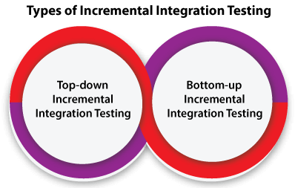
Let's see a brief introduction of these types of integration testing:
1. Top-down Incremental Integration Testing
In this approach, we will add the modules step by step or incrementally and test the data flow between them. We have to ensure that the modules we are adding are the child of the earlier ones.
2. Bottom-up Incremental Integration Testing
In the bottom-up approach, we will add the modules incrementally and check the data flow between modules. And also, ensure that the module we are adding is the parent of the earlier ones.

Non-Incremental Integration Testing/ Big Bang Method
Whenever the data flow is complex and very difficult to classify a parent and a child, we will go for the non-incremental integration approach. The non-incremental method is also known as the Big Bang method.
To get the complete information about integration testing and its type refers to the following link: https://www.javatpoint.com/integration-testing.

3. System Testing
Whenever we are done with the unit and integration testing, we can proceed with the system testing.
In system testing, the test environment is parallel to the production environment. It is also known as end-to-end testing.
In this type of testing, we will undergo each attribute of the software and test if the end feature works according to the business requirement. And analysis the software product as a complete system.
Click on the below link to get the complete information about system testing: https://www.javatpoint.com/system-testing.

Non-function Testing
The next part of black-box testing is non-functional testing. It provides detailed information on software product performance and used technologies.
Non-functional testing will help us minimize the risk of production and related costs of the software.
Non-functional testing is a combination of performance, load, stress, usability and, compatibility testing.
For more information about Non-functional testing, refer to the following link: https://www.javatpoint.com/non-functional-testing.

Types of Non-functional Testing
Non-functional testing categorized into different parts of testing, which we are going to discuss further:
- Performance Testing
- Usability Testing
- Compatibility Testing
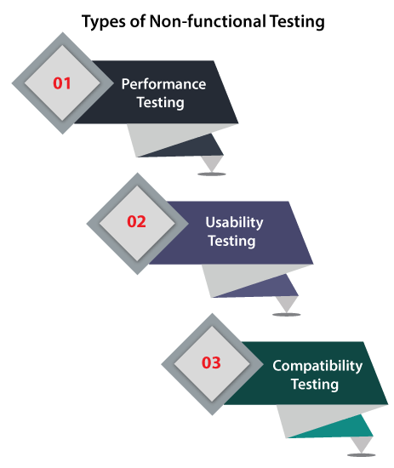

1. Performance Testing
In performance testing, the test engineer will test the working of an application by applying some load.
In this type of non-functional testing, the test engineer will only focus on several aspects, such as Response time, Load, scalability, and Stability of the software or an application.
Classification of Performance Testing
Performance testing includes the various types of testing, which are as follows:
- Load Testing
- Stress Testing
- Scalability Testing
- Stability Testing
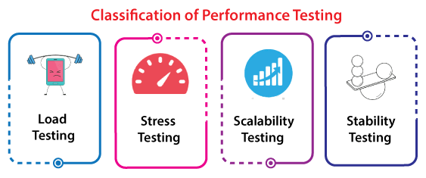
- Load Testing
While executing the performance testing, we will apply some load on the particular application to check the application's performance, known as load testing. Here, the load could be less than or equal to the desired load.
It will help us to detect the highest operating volume of the software and bottlenecks.
To get the complete information related to the load testing refers to the below link:
https://www.javatpoint.com/load-testing.
- Stress Testing
It is used to analyze the user-friendliness and robustness of the software beyond the common functional limits.
Primarily, stress testing is used for critical software, but it can also be used for all types of software applications.
Refers to the below link for in-depth knowledge of stress testing: https://www.javatpoint.com/stress-testing.
- Scalability Testing
To analysis, the application's performance by enhancing or reducing the load in particular balances is known as scalability testing.
In scalability testing, we can also check the system, processes, or database's ability to meet an upward need. And in this, the Test Cases are designed and implemented efficiently.
Click on the following link to get the detailed information related to the scalability testing:
https://www.javatpoint.com/scalability-testing.
- Stability Testing
Stability testing is a procedure where we evaluate the application's performance by applying the load for a precise time.
It mainly checks the constancy problems of the application and the efficiency of a developed product. In this type of testing, we can rapidly find the system's defect even in a stressful situation.
To get detailed information about the stability testing refers to the below link:
https://www.javatpoint.com/stability-testing.

2. Usability Testing
Another type of non-functional testing is usability testing. In usability testing, we will analyze the user-friendliness of an application and detect the bugs in the software's end-user interface.
Here, the term user-friendliness defines the following aspects of an application:
- The application should be easy to understand, which means that all the features must be visible to end-users.
- The application's look and feel should be good that means the application should be pleasant looking and make a feel to the end-user to use it.
For more information about usability testing, we can refer to the following link:
https://www.javatpoint.com/usability-testing.

3. Compatibility Testing
In compatibility testing, we will check the functionality of an application in specific hardware and software environments. Once the application is functionally stable then only, we go for compatibility testing.
Here, software means we can test the application on the different operating systems and other browsers, and hardware means we can test the application on different sizes.
To get a thorough knowledge of compatibility testing refer to the below link:
https://www.javatpoint.com/compatibility-testing.

Grey Box Testing
Another part of manual testing is Grey box testing. It is a collaboration of black box and white box testing.
Since, the grey box testing includes access to internal coding for designing test cases. Grey box testing is performed by a person who knows coding as well as testing.
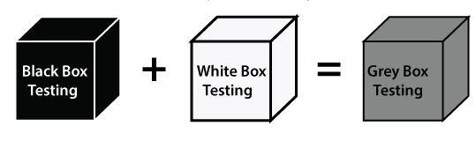
In other words, we can say that if a single-person team done both white box and black-box testing, it is considered grey box testing.
To get the in-details information about Grey box testing, we can refer to the below link:
https://www.javatpoint.com/grey-box-testing.

Automation Testing
The most significant part of Software testing is Automation testing. It uses specific tools to automate manual design test cases without any human interference.
Automation testing is the best way to enhance the efficiency, productivity, and coverage of Software testing.
It is used to re-run the test scenarios, which were executed manually, quickly, and repeatedly.
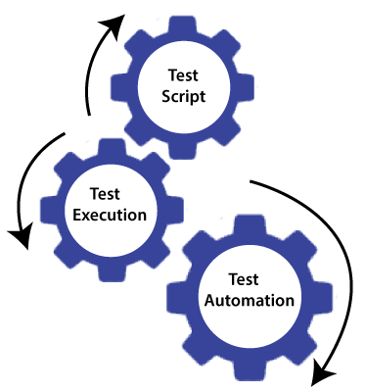
In other words, we can say that whenever we are testing an application by using some tools is known as automation testing.
We will go for automation testing when various releases or several regression cycles goes on the application or software. We cannot write the test script or perform the automation testing without understanding the programming language.
For more information about automation testing, we can refer to the below link:
https://www.javatpoint.com/automation-testing.

Some other types of Software Testing
In software testing, we also have some other types of testing that are not part of any above discussed testing, but those testing are required while testing any software or an application.
- Smoke Testing
- Sanity Testing
- Regression Testing
- User Acceptance Testing
- Exploratory Testing
- Adhoc Testing
- Security Testing
- Globalization Testing
Let's understand those types of testing one by one:
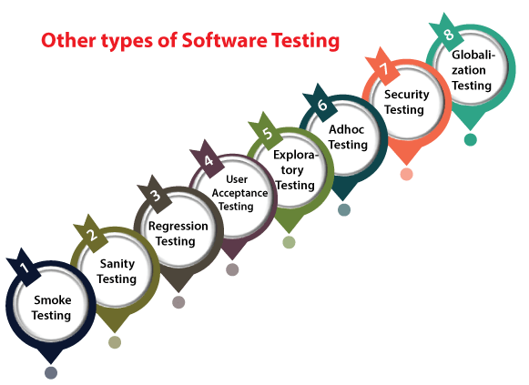
In smoke testing, we will test an application's basic and critical features before doing one round of deep and rigorous testing.
Or before checking all possible positive and negative values is known as smoke testing. Analyzing the workflow of the application's core and main functions is the main objective of performing the smoke testing.
For more information about smoke testing, refers to the following link:
https://www.javatpoint.com/smoke-testing.

Sanity Testing
It is used to ensure that all the bugs have been fixed and no added issues come into existence due to these changes. Sanity testing is unscripted, which means we cannot documented it. It checks the correctness of the newly added features and components.
To get the in-detail information about sanity testing, we can refer to the below link:
https://www.javatpoint.com/sanity-testing.

Regression Testing
Regression testing is the most commonly used type of software testing. Here, the term regression implies that we have to re-test those parts of an unaffected application.
Regression testing is the most suitable testing for automation tools. As per the project type and accessibility of resources, regression testing can be similar to Retesting.
Whenever a bug is fixed by the developers and then testing the other features of the applications that might be simulated because of the bug fixing is known as regression testing.
In other words, we can say that whenever there is a new release for some project, then we can perform Regression Testing, and due to a new feature may affect the old features in the earlier releases.
To get thorough knowledge related to regression testing, refer to the below link:
https://www.javatpoint.com/regression-testing.

User Acceptance Testing
The User acceptance testing (UAT) is done by the individual team known as domain expert/customer or the client. And knowing the application before accepting the final product is called as user acceptance testing.
In user acceptance testing, we analyze the business scenarios, and real-time scenarios on the distinct environment called the UAT environment. In this testing, we will test the application before UAI for customer approval.
For more information about the User acceptance testing, click on the below link:
https://www.javatpoint.com/acceptance-testing.

Exploratory Testing
Whenever the requirement is missing, early iteration is required, and the testing team has experienced testers when we have a critical application. New test engineer entered into the team then we go for the exploratory testing.
To execute the exploratory testing, we will first go through the application in all possible ways, make a test document, understand the flow of the application, and then test the application.
Click on the following link to get the complete information about exploratory testing:
https://www.javatpoint.com/exploratory-testing.

Adhoc Testing
Testing the application randomly as soon as the build is in the checked sequence is known as Adhoc testing.
It is also called Monkey testing and Gorilla testing. In Adhoc testing, we will check the application in contradiction of the client's requirements; that's why it is also known as negative testing.
When the end-user using the application casually, and he/she may detect a bug. Still, the specialized test engineer uses the software thoroughly, so he/she may not identify a similar detection.
Refers to the following to get the in-detail information about Adhoc testing:
https://www.javatpoint.com/adhoc-testing.
Security Testing
It is an essential part of software testing, used to determine the weakness, risks, or threats in the software application.
The execution of security testing will help us to avoid the nasty attack from outsiders and ensure our software applications' security.
In other words, we can say that security testing is mainly used to define that the data will be safe and endure the software's working process.
To get the complete detail about security testing, refer to the below link: https://www.javatpoint.com/security-testing.

Globalization Testing
Another type of software testing is Globalization testing. Globalization testing is used to check the developed software for multiple languages or not. Here, the words globalization means enlightening the application or software for various languages.
Globalization testing is used to make sure that the application will support multiple languages and multiple features.
In present scenarios, we can see the enhancement in several technologies as the applications are prepared to be used globally.
Refer to the following link to get the completed information related to the globalization testing:
https://www.javatpoint.com/globalization-testing.

Conclusion
In the tutorial, we have discussed various types of software testing. But there is still a list of more than 100+ categories of testing. However, each kind of testing is not used in all types of projects.
We have discussed the most commonly used types of Software Testing like black-box testing, white box testing, functional testing, non-functional testing, regression testing, Adhoc testing, etc.
Also, there are alternate classifications or processes used in diverse organizations, but the general concept is similar all over the place.
These testing types, processes, and execution approaches keep changing when the project, requirements, and scope change.

Levels of Testing
In this section, we are going to understand the various levels of software testing.
As we learned in the earlier section of the software testing tutorial that testing any application or software, the test engineer needs to follow multiple testing techniques.
In order to detect an error, we will implement software testing; therefore, all the errors can be removed to find a product with more excellent quality.

What are the levels of Software Testing?
Testing levels are the procedure for finding the missing areas and avoiding overlapping and repetition between the development life cycle stages. We have already seen the various phases such as Requirement collection, designing, coding testing, deployment, and maintenance of SDLC (Software Development Life Cycle).
In order to test any application, we need to go through all the above phases of SDLC. Like SDLC, we have multiple levels of testing, which help us maintain the quality of the software.

Different Levels of Testing
The levels of software testing involve the different methodologies, which can be used while we are performing the software testing.
In software testing, we have four different levels of testing, which are as discussed below:
- Unit Testing
- Integration Testing
- System Testing
- Acceptance Testing
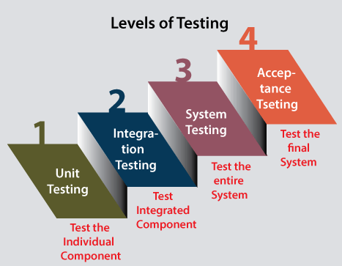
As we can see in the above image that all of these testing levels have a specific objective which specifies the value to the software development lifecycle.
For our better understanding, let's see them one by one:

Level1: Unit Testing
Unit testing is the first level of software testing, which is used to test if software modules are satisfying the given requirement or not.
The first level of testing involves analyzing each unit or an individual component of the software application.
Unit testing is also the first level of functional testing. The primary purpose of executing unit testing is to validate unit components with their performance.
A unit component is an individual function or regulation of the application, or we can say that it is the smallest testable part of the software. The reason of performing the unit testing is to test the correctness of inaccessible code.
Unit testing will help the test engineer and developers in order to understand the base of code that makes them able to change defect causing code quickly. The developers implement the unit.
For more information on unit testing, refers to the following link:
https://www.javatpoint.com/unit-testing.

Level2: Integration Testing
The second level of software testing is the integration testing. The integration testing process comes after unit testing.
It is mainly used to test the data flow from one module or component to other modules.
In integration testing, the test engineer tests the units or separate components or modules of the software in a group.
The primary purpose of executing the integration testing is to identify the defects at the interaction between integrated components or units.
When each component or module works separately, we need to check the data flow between the dependent modules, and this process is known as integration testing.
We only go for the integration testing when the functional testing has been completed successfully on each application module.
In simple words, we can say that integration testing aims to evaluate the accuracy of communication among all the modules.
For more information on integration testing, refers to the following link:
https://www.javatpoint.com/integration-testing.

Level3: System Testing
The third level of software testing is system testing, which is used to test the software's functional and non-functional requirements.
It is end-to-end testing where the testing environment is parallel to the production environment. In the third level of software testing, we will test the application as a whole system.
To check the end-to-end flow of an application or the software as a user is known as System testing.
In system testing, we will go through all the necessary modules of an application and test if the end features or the end business works fine, and test the product as a complete system.
In simple words, we can say that System testing is a sequence of different types of tests to implement and examine the entire working of an integrated software computer system against requirements.
For more information on System testing, refers to the following link:
https://www.javatpoint.com/system-testing.

Level4: Acceptance Testing
The last and fourth level of software testing is acceptance testing, which is used to evaluate whether a specification or the requirements are met as per its delivery.
The software has passed through three testing levels (Unit Testing, Integration Testing, System Testing). Some minor errors can still be identified when the end-user uses the system in the actual scenario.
In simple words, we can say that Acceptance testing is the squeezing of all the testing processes that are previously done.
The acceptance testing is also known as User acceptance testing (UAT) and is done by the customer before accepting the final product.
Usually, UAT is done by the domain expert (customer) for their satisfaction and checks whether the application is working according to given business scenarios and real-time scenarios.
For more information on System testing, refers to the following link:
https://www.javatpoint.com/acceptance-testing.

Conclusion
In this tutorial, we have learned all the levels of testing. And we can conclude that tests are grouped based on where they are added in the Software development life cycle.
A level of software testing is a process where every unit or component of a software or system is tested.
The main reason for implementing the levels of testing is to make the software testing process efficient and easy to find all possible test cases at a specific level.
To check the behavior or performance of software testing, we have various testing levels. The above-described software testing levels are developed to identify missing areas and understanding between the development life cycle conditions.
All these SDLC models' phases (requirement gathering, analysis, design, coding or execution, testing, deployment, and maintenance) undergo the process of software testing levels.

Test Maturity Model
In this section, we are going to explore and discuss the following topics related to Test Maturity Model, and we will also analyze the importance of TMM when it is applied to software testing process.
- What is Test Maturity Model?
- The five levels of the test maturity model
- Difference between TMM and CMM
- Benefits of the test maturity model
Before going deep into all the above mention topics, firstly, we will understand the Test maturity Model.

What is Test Maturity Model?
When software is tested, there are so many techniques are followed to accomplish maximum quality and minimize defects or errors.
Test Maturity Model is one of such models which has a set of structured levels and it is based on the Capability Maturity Model (CMM).
The Illinois Institute of Technology initially developed the test maturity model, but now it is managed by TMMI Foundation.
We have used the Test maturity model to develop strategies and a reference framework for increasing the testing process.
Presently, the TMM is replaced by Test Maturity Model Integration (TMMI) which is five level model that provides a framework to measure the maturity of the testing processes.
We need to perform the testing phase of the Software Development Life Cycle very efficiently as it plays a significant role in order to complete any project successfully.
Test Maturity Model or TMMi is one such process that has made software testing life cycle more resourceful. It is one such model with a detailed model for test process improvement.
A Test maturity model's primary purpose is to find the maturity and provide targets to enhance the software testing process in order to accomplish development. It can be used as a stand-alone model or completed with any process improvement model.

Why we need TMMi?
The Test Maturity Model Integration/TMMi is progressively discover its way into many IT organizations to update and ease their testing process.
But the question arises, why do we need the TMMi model?
Below are a few significant points, which are helpful for us to understand the need for TMMi.
- The Test Maturity Model Integration (TMMi) helps in the assessment and enhancement of the testing process.
- The implementation of this model improves the test process, the software quality, and the efficiency of test engineering.
- Several software process developments such as CMM/CMMIprovide limited consideration to testing. Hence, we need something like TMMI for a process, which is mainly made for testing.
- However, many efforts were made to expand the testing process; still, zero defects are identified from reality for the software engineering. So, TMMi is the further attempt to achieve zero defects.
- It is a test process improvement model that can integrate with other process development models and be used as a standalone model.

Levels of Test Maturity Model
The test Maturity model contains five different levels, which will help the organization fix its maturity. To achieving a higher level of test maturity, these five levels will lead us to identify the next development steps:
Let's understand the five levels of TMM one by one in detail:
- Initialization
- Definition
- Integration
- Measurement and Management
- Optimization
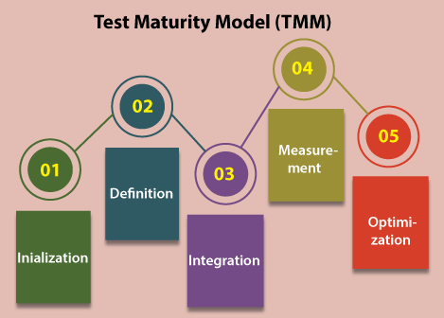

Level1: Initialization
- Initializationis the first level of the Test maturity model. There is no defined testing process in the first level of TMM.
- The purpose behind initialization levels is to ensure that the software should execute successfully and there is no obstruction.
- At this level, there will be Exploratory or Adhoc testing performed on the software, and there are no quality checks before delivering the product.

Level2: Definition
- The second level of a Test maturity model is Definition, which is all about defining the requirements.
- We can create the test strategies, test plans, and test cases in order to build a software according to the given requirements by the client,
- The critical purpose of the definition level is to ensure that the software product implements according to the requirements, develop testing, debugging goals, and policies that are followed consistently.

Level3: Integration
- The third level of a test maturity model is
- The primary purpose of executing this level into the test maturity model is to ensure that the testing is integrated with the software lifecycle and becomes a part of it.
- For instance, as we know that the V model has both development and testing phases, which means that the testing comes after when the development process is completed.
- The entire testing objectives are based on risk management as testing is implemented independently.

Level4: Measurement and Management
- The fourth level of a Test maturity model is measurement and management where testing becomes part of all the activities in the software life cycle.
- Here, we will be managing and measuring the requirements.
- The primary purpose of executing this level into the test maturity model is to ensure that the establishment of a test measurement program.
- To determine the quality measures this level, include reviewing, requirements gathering, and design of the software.

Level5: Optimization
- The last and fifth level of the Test Maturity level is optimization.
- The essential purpose of this level is to optimize the test process itself.
- In simple words, we can say that the testing processes are verified, and measures are taken to enhance the further process.
- In this, quality control and bug inhibition are performed during the software life cycle.
- At the optimization level, we mainly focus on defect prevention rather than defect detection and with the help of the different tools, we can perform this testing.
After seeing all the five levels of the test maturity model, we can say that each level has its role and responsibility. And the objective of all the levels has to create its well-defined structure.
The primary concept of the Test Maturity Model was taken from Capability Maturity Model (CMM).
Essentially it is a structured tool that is used for software development and a model to support different business processes. In Test Maturity Model, the term Maturity is measured by the degree of optimized processes.

Difference between CMM & TMM
Some of the significant difference between CMM and TMM models are as discussed in the following table:
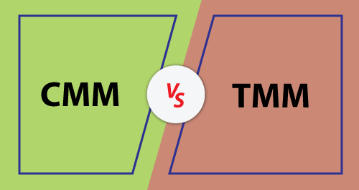
S.No. | CMM | TMM
1. | The capability Maturity Model or CMM is used to consider the maturity of an organization's software processes. | Test Maturity Model or TMM specify testing and is related to checking the quality of the software testing model.
2. | It has significantly controlled the software development procedures. | It is used as a corresponding framework along with CMMi.
3. | CMMi mainly focuses on software development practices. | The complete focuses of the TMMi framework are on the processes which are applied to software testing to enhance the quality and efficiency of the testing process.

Advantages of Test Maturity Model
Let's see some of the significant advantages of using the Test Maturity Model (TMM) in an organization:
Defect prevention
- As we know from the above explanation, TMM emphasizes defect prevention rather than bug detection by making the testing process a part of all phases of the software development life cycle.
- It also makes sure that the maximum defects are identified and the mostly final product is defect-free.
Organized
- As we have already discussed the five levels of TMM and we can conclude that each level is well defined and has a particular purpose to achieve, which makes the test maturity model a well-organized model with solid objectives.
Clear requirements
- When the necessities of the software, designs are reviewed, test plans, and test cases are tested in contradiction of requirements. Or if the primary test aim is more precise, then we can achieve more accurate testing.
Assurance of quality
- We can achieve a higher quality of the product if we integrate testing with all the phases of the software life cycle.
- Analysis of test processes would enhance the outcome, which assures a good quality product.

Overview
As compared to the CMM (Compatibility Maturity Model), the TMM (Test Maturity Model) is equally a new topic, but the primary purpose of both the models continues the same.
If we want to display how a structured set of levels leads to the high-quality expected output by enhancing the processes, and performance of an organization.
For any organization, software maintenance is an expensive and time-consuming process when bugs are identified after project delivery.
Therefore, while identifying the defects is significant, it is also necessary that software makes minor errors throughout the development phase. A standard testing process like TMM can help us in order to accomplish this.
As we understood from the above discussion, the Test Maturity Model is specially designed to address testing. And to help the organization in order to enhance the maturity of their testing exercises.
To make sure the enhancement in testing processes in an IT organization, the TMMi model was developed. And according to the business, these models can be generalized and applied for improved results.
It is introduced because the previous model did not focus on the testing processes.
Still, the TMMi model is developed to focus on planning and development, and the CMMi model procedures guide it.

How to write Test Cases – Software Testing
• Read

Software testing is known as a process for validating and verifying the working of a software/application. It makes sure that the software is working without any errors, bugs, or any other issues and gives the expected output to the user. The software testing process isn’t limited to finding faults in the present software but also finding measures to upgrade the software in various factors such as efficiency, usability, and accuracy. So, to test software the software testing provides a particular format called a Test Case.
This article focuses on discussing the following topics in the Test Case:
- What is a Test Case?
- Test Case vs Test Scenario.
- When do we Write Test Cases?
- Why Write Test Cases?
- Test Case Template.
- Best Practice for Writing Test Cases.
- Test Case Management Tools.
- Formal and Informal Test Case.
- Types of Test Cases.
- Example.

What is a Test Case?
A test case is a defined format for software testing required to check if a particular application/software is working or not. A test case consists of a certain set of conditions that need to be checked to test an application or software i.e. in more simple terms when conditions are checked it checks if the resultant output meets with the expected output or not. A test case consists of various parameters such as ID, condition, steps, input, expected result, result, status, and remarks.
Parameters of a Test Case:
- Module Name: Subject or title that defines the functionality of the test.
- Test Case Id: A unique identifier assigned to every single condition in a test case.
- Tester Name: The name of the person who would be carrying out the test.
- Test scenario: The test scenario provides a brief description to the tester, as in providing a small overview to know about what needs to be performed and the small features, and components of the test.
- Test Case Description: The condition required to be checked for a given software. for eg. Check if only numbers validation is working or not for an age input box.
- Test Steps: Steps to be performed for the checking of the condition.
- Prerequisite: The conditions required to be fulfilled before the start of the test process.
- Test Priority: As the name suggests gives priority to the test cases that had to be performed first, or are more important and that could be performed later.
- Test Data: The inputs to be taken while checking for the conditions.
- Test Expected Result: The output which should be expected at the end of the test.
- Test parameters: Parameters assigned to a particular test case.
- Actual Result: The output that is displayed at the end.
- Environment Information: The environment in which the test is being performed, such as the operating system, security information, the software name, software version, etc.
- Status: The status of tests such as pass, fail, NA, etc.
- Comments: Remarks on the test regarding the test for the betterment of the software.

Test Case vs Test Scenario
Below are some of the points of difference between a test case and a test scenario:
Parameter | Test Case | Test Scenario
Definition | A test case is a defined format for software testing required to check if a particular application/software/module is working or not. Here we check for different conditions regarding the same. | The test Scenario provides a small description of what needs to be performed based on the use case.
Level of detailing | Test cases are more detailed with several parameters. | Test Scenario provides a small description, mostly one-line statements.
Action Level | Test cases are low-level actions. | Test scenarios are high-level actions.
Derived from | Test cases are mostly derived from test scenarios. | Test scenarios are derived from documents like BRS, SRS, etc.
Objective | It focuses on “What to test” and “How to test”. | It focuses more on ‘What to test”.
Resources required | Test cases require more resources for documentation and execution. | Fewer resources are required to write test scenarios.
Inputs | It includes all positive and negative inputs, expected results, navigation steps, etc. | They are one-liner statements.
Time requirement | It requires more time compared to test scenarios. | Test scenarios require less time.
Maintenance | They are hard to maintain. | They require less time to maintain.

When do we Write Test Cases?
Test cases are written in different situations:
- Before development: Test cases could be written before the actual coding as that would help to identify the requirement of the product/software and carry out the test later when the product/software gets developed.
- After development: Test cases are also written directly after coming up with a product/software or after developing the feature but before the launching of a product/software as needed to test the working of that particular feature.
- During development: Test cases are sometimes written during the development time, parallelly. so whenever a part of the module/software gets developed it gets tested as well.
So, test cases are written in such cases, as test cases help in further development and make sure that we are meeting all the needed requirements.

Why Write Test Cases?
Test cases are one of the most important aspects of software engineering, as they define how the testing would be carried out. Test cases are carried out for a very simple reason, to check if the software works or not. There are many advantages of writing test cases:
- To check whether the software meets customer expectations: Test cases help to check if a particular module/software is meeting the specified requirement or not.
- To check software consistency with conditions: Test cases determine if a particular module/software works with a given set of conditions.
- Narrow down software updates: Test cases help to narrow down the software needs and required updates.
- Better test coverage: Test cases help to make sure that all possible scenarios are covered and documented.
- For consistency in test execution: Test cases help to maintain consistency in test execution. A well-documented test case helps the tester to just have a look at the test case and start testing the application.
- Helpful during maintenance: Test cases are detailed which makes them helpful during the maintenance phase.

Test Case Template
Let’s look at a basic test case template for the login functionality.
- The Test case template contains the header section which has a set of parameters that provides information about the test case such as the tester’s name, test case description, Prerequisite, etc.
- The body section contains the actual test case content, such as test ID, test steps, test input, expected result, etc.
Below is the table that shows the basic template of a test case:
Fields | Description
Test Case ID | Each test case should have a unique ID.
Test Case Description | Each test case should have a proper description to let testers know what the test case is about.
Pre-Conditions | Conditions that are required to be satisfied before executing the test case.
Test Steps | Mention all test steps in detail and to be executed from the end-user’s perspective.
Test Data | Test data could be used as input for the test cases.
Expected Result | The result is expected after executing the test cases.
Post Condition | Conditions need to be fulfilled when the test cases are successfully executed.
Actual Result | The result that which system shows once the test case is executed.
Status | Set the status as Pass or Fail on the expected result against the actual result.
Project Name | Name of the project to which the test case belongs.
Module Name | Name of the module to which the test case belongs.
Reference Document | Mention the path of the reference document.
Created By | Name of the tester who created the test cases.
Date of Creation | Date of creation of test cases.
Reviewed By | Name of the tester who reviews the test case.
Date of Review | When the test cases were reviewed.
Executed By | Name of the tester who executed the test case.
Date of Execution | Date when the test cases were executed.
Comments | Include comments which help the team to understand the test cases.
In the given template below it’s identifiable that the section from module name to test scenario is the header section while the table that lies below the test scenario (from test case ID to comments) is the body of the test case template.
Here a test case template for login functionality has been created with its parameters and values.
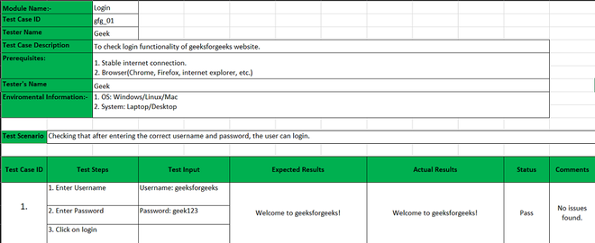
Test Case Template

Best Practice for Writing Test Case
There are certain practices that one could follow while writing the test cases that would be considered beneficial.
- Simple and clear: Test cases need to be very concise, clear, and transparent. They should be easy and simple to understand not only for oneself but for others as well.
- Maintaining the client/customer/end-user requirements must be unique: While writing the test cases, it’s necessary to make sure that they aren’t being written over and over again and that each case is different from the others.
- Zero Assumptions: Test cases should not contain assumed data, and don’t come up with features/modules that don’t exist.
- Traceability: Test cases should be traceable for future reference, so while writing it’s important to keep that in mind,
- Different input data: While writing test cases, all types of data must be taken into consideration.
- Strong module name: The module name should be self-explanatory while writing the test case.
- Minimal Description: The description of a test case should be small, one or two lines are normally considered good practice, but it should give the basic overview properly.
- Maximum conditions: All kinds of conditions should be taken into consideration while writing a test, increasing the effectiveness.
- Meeting requirements: While writing the test case the client/customer/end-user requirements must be met.
- Repetitive Results: The test case must be written in such a way that it should provide the same result.
- Different Techniques: Sometimes testing all conditions might not be possible but using different testing with different test cases could help to check every aspect of a software.
- Create test cases with the end user’s perspective: Create test cases by keeping end-user in mind and the test cases must meet customer requirements.
- Use unique Test Case ID: It is considered a good practice to use a unique Test Case ID for the test cases following a naming convention for better understanding.
- Add proper preconditions and postconditions: Preconditions and postconditions for the test cases must be mentioned properly and clearly.
- Test cases should be reusable: There are times when the developer updates the code, then the testers need to update the test cases to meet the changing requirements.
- Specify the exact expected outcome: Include the exact expected result, which tells us what will be result of a particular test step.

Test Case Management Tools
Test management tools help to manage the test cases. These tools are automated tools that decrease the time and effort of a tester as compared to the traditional way. Some test case management tools include advanced dashboards, easier bug, and progress tracking as well as management, custom test case templates, integration of test cases, inviting guest testers, managing team requirements and plans, and much more.
Below are some of the test case management tools:
- Testpad: Testpad is a simple tool that makes test case management easier. The software’s main motto says that it aims to find a bug that matters. A few features of Testpad include manual testing, reports of the test cases and software, dragging and dropping to make testing easier, inviting guest testers by email, building custom templates, and much more.
- TestCaseLab: TestCaseLab is easily manageable for the test cases and could swiftly integrate them with bug trackers. The features of TestCaseLab include Custom test cases, Test Runs, Integrations of test cases, Test Plans, tags and priority for test cases, search by name of test cases, description, tags, etc.
- TestRail: TestRail is another platform that aims to make test case management easier, it streamlines the software testing processes and along with more visibility into QA. The basic features of TestRail include management for test cases, plans, and runs, more test coverage, real-time insights into the QA progress, etc.
- TestLodge: TestLodge is a test case management tool that helps the entire team manage their requirements, test plans, test cases, and test runs all in one single place and with no user limit. The basic features of TestLodge include Test Plans, Test Runs, a Dashboard, a Test Suite, and many more.

Formal and Informal Test Case
- Formal Test Cases: Formal test cases are test cases that follow the basic test case format. It contains the test case parameters such as conditions, ID, Module name, etc. Formal Test cases have set input data and expected results, they are performed as per the given order of steps.
- Informal Test Cases: Informal test cases are test cases that don’t follow the basic test case format. In these, as the tests are performed the test cases are written in real-time then pre-writing them, and the input and expected results are not predefined as well.

Types of Test Cases
- Functionality Test Case: The functionality test case is to determine if the interface of the software works smoothly with the rest of the system and its users or not. Black box testing is used while checking for this test case, as we check everything externally and not internally for this test case.
- Unit Test Case: In unit test case is where the individual part or a single unit of the software is tested. Here each unit/ individual part is tested, and we create a different test case for each unit.
- User Interface Test Case: The UI test or user interface test is when every component of the UI that the user would come in contact with is tested. It is to test if the UI components requirement made by the user are fulfilled or not.
- Integration Test Case: Integration testing is when all the units of the software are combined and then they are tested. It is to check that each component and its units work together without any issues.
- Performance Test Case: The performance test case helps to determine response time as well as the overall effectiveness of the system/software. It’s to see if the application will handle real-world expectations.
- Database Test Case: Also known as back-end testing or data testing checks that everything works fine concerning the database. Testing cases for tables, schema, triggers, etc. are done.
- Security Test Case: The security test case helps to determine that the application restricts actions as well as permissions wherever necessary. Encryption and authentication are considered as main objectives of the security test case. The security test case is done to protect and safeguard the data of the software.
- Usability Test Case: Also known as a user experience test case, it checks how user-friendly or easy to approach a software would be. Usability test cases are designed by the User experience team and performed by the testing team.
- User Acceptance Test Case: The user acceptance case is prepared by the testing team but the user/client does the testing and review if they work in the real-world environment.

Example
Below is an example of preparing various test cases for a login page with a username and password.
Unit Test case: Here we are only checking if the username validates at least for the length of eight characters.
Test Id | Test Condition | Test Steps | Test Input | Test Expected Result | Actual Result | Status | Remarks
1. | Check if the username field accepts the input of thirteen characters. | 1. Give input | geeksforgeeks | Accepts for thirteen characters. | Accepts for thirteen characters. | Pass | None
Here it is only checked whether the passing of input of thirteen characters is valid or not. So since the character word ‘geeksforgeeks’ is entered then the test is successful it would have failed for any other test case.
Functionality Test case: Here it is checked whether the username and password both work together on the login click.
Test Id | Test Condition | Test Steps | Test Input | Test Expected Result | Actual Result | Status | Remarks
1. | Check that with the correct username and password able to log in. | 1. Enter the username  2. Enter the password  3. Click on the login | username: geeks for geeks  password: geeksforever | Login successful | Login successful | Pass | None
2. | Check that if with an incorrect username and password able to not login. | 1. Enter the username  2. Enter the password  3. Click on the login | username: geeksforgeeks  password: geekstogether | Login unsuccessful | Login unsuccessful | Pass | None
Here it is being checked whether passing wrong and right inputs and if the login functionality is working or not, it’s showing login is successful for the right credentials and unsuccessful for the wrong ones, hence both tests have passed otherwise would have failed.
User Acceptance Test Case: Here the user feedback is taken if the login page is loading properly or not.
Test Id | Test Condition | Test Steps | Test Input | Test Expected Result | Actual Result | Status | Remarks
1. | Check if the loading page loading efficiently for the client. | 1. Click on the login button. | None | Welcome to the login page. | Welcome to the login page. | Fail | The login page is not loaded due to a browser compatibility issue on the user’s side.
Here it is being checked in by clicking on the login button if the page is loaded and the ‘Welcome to login page’ message is displayed. The test has failed here as the page was not loaded due to a browser compatibility issue, it would have loaded if the test had passed.

